Bug 1:

**Player cannot reach betting limit:**

Limit set to 0, but game ends with player still with 5 (dollars) remaining.

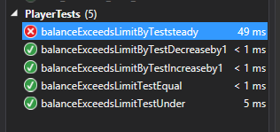

Test Name: balanceExceedsLimitByTeststeady

Test Outcome: Failed

Test Duration: 0:00:00.0495847

Result Message: Assert.IsTrue failed.

Test Name: balanceExceedsLimitByTestDecreaseby1

Test Outcome: Passed

Test Duration: 0:00:00.0001068

Test Name: balanceExceedsLimitByTestIncreaseby1

Test Outcome: Passed

Test Duration: 0:00:00.0000904

Test Name: balanceExceedsLimitTestEqual

Test Outcome: Passed

Test Duration: 0:00:00.0001499

Test Name: balanceExceedsLimitTestUnder

Test Outcome: Passed

Test Duration: 0:00:00.0001499